Week 7: User Authentication and Session Management

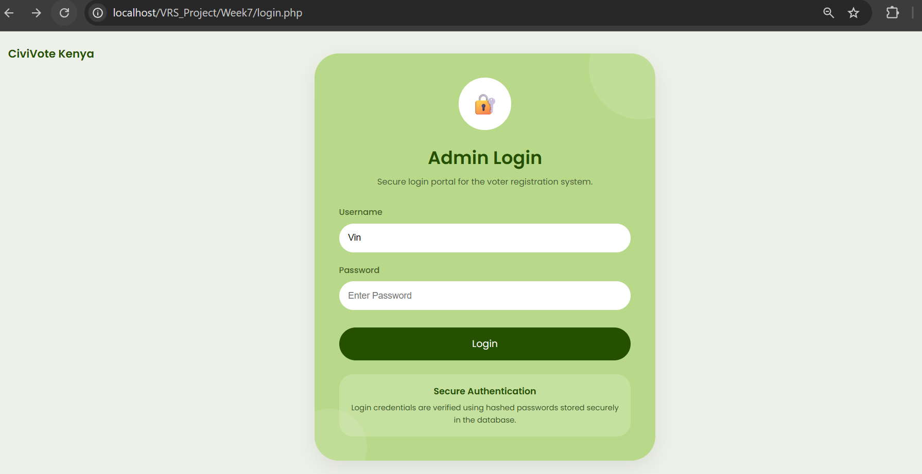
Figure 34: User Login Page for the CiviVote Kenya System.

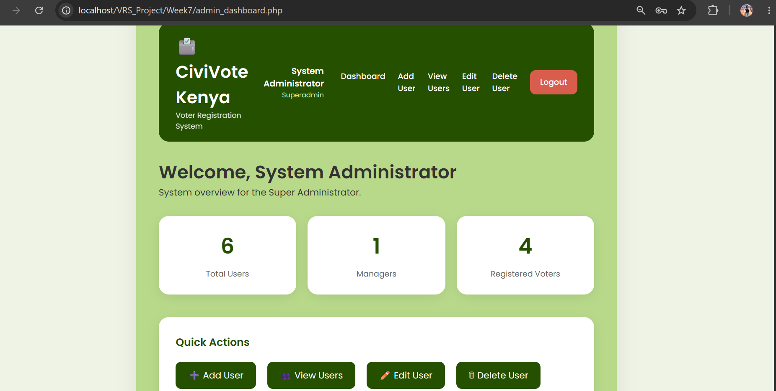
Figure 35: Super Administrator Dashboard Displayed After Successful Authentication.

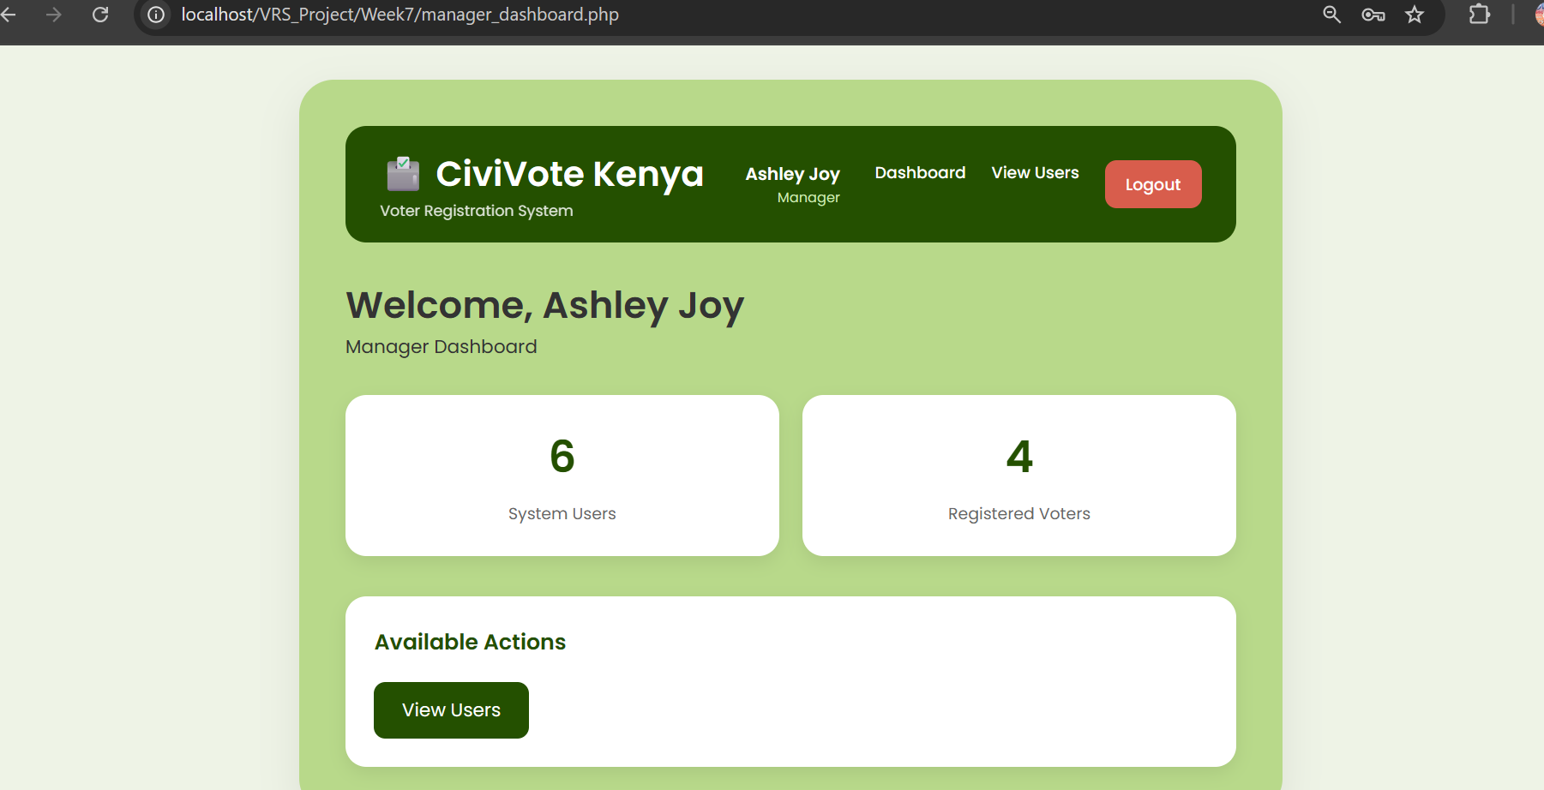
Figure 36: Manager Dashboard After Successful Login.

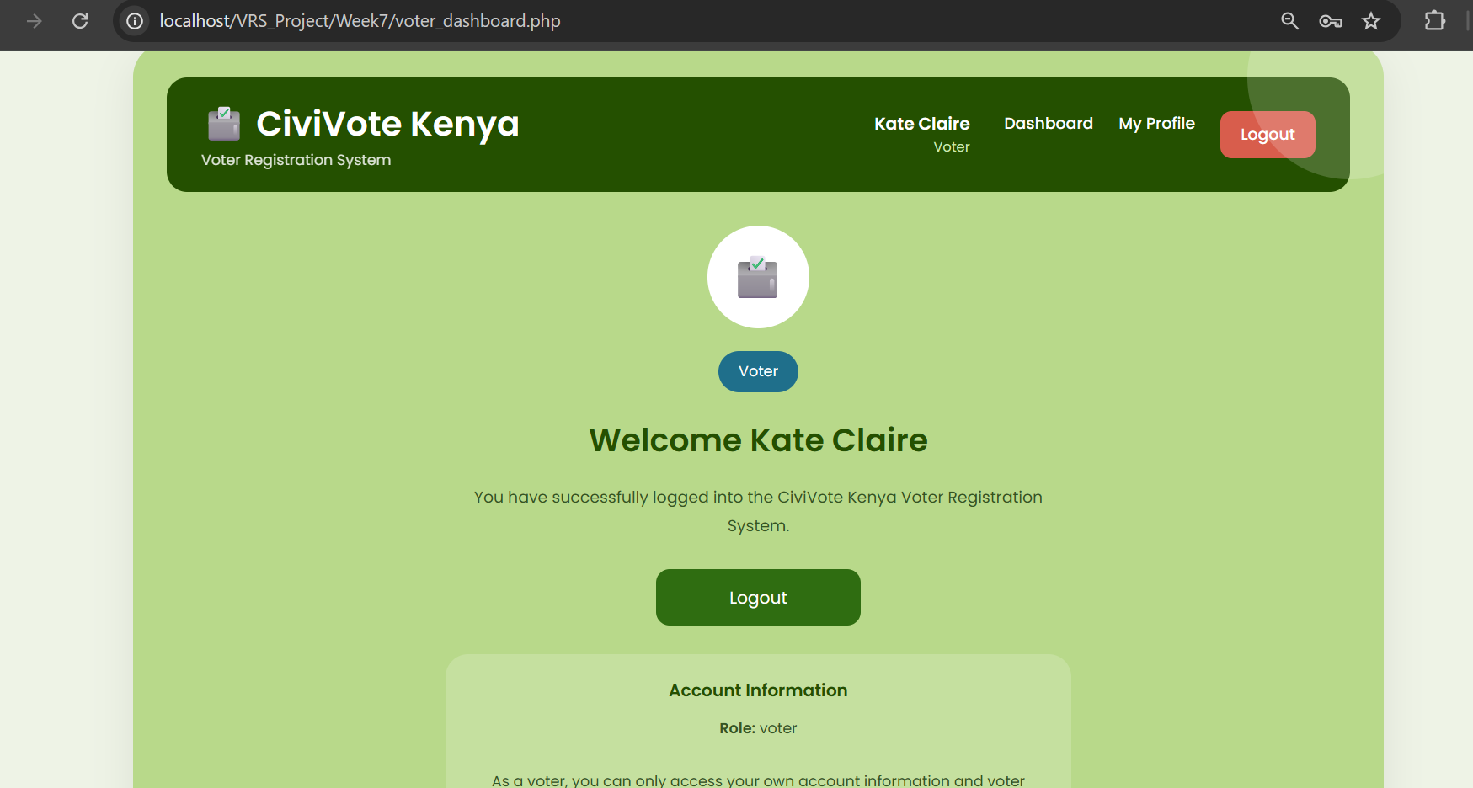
Figure 37: Voter Dashboard After Successful Login.
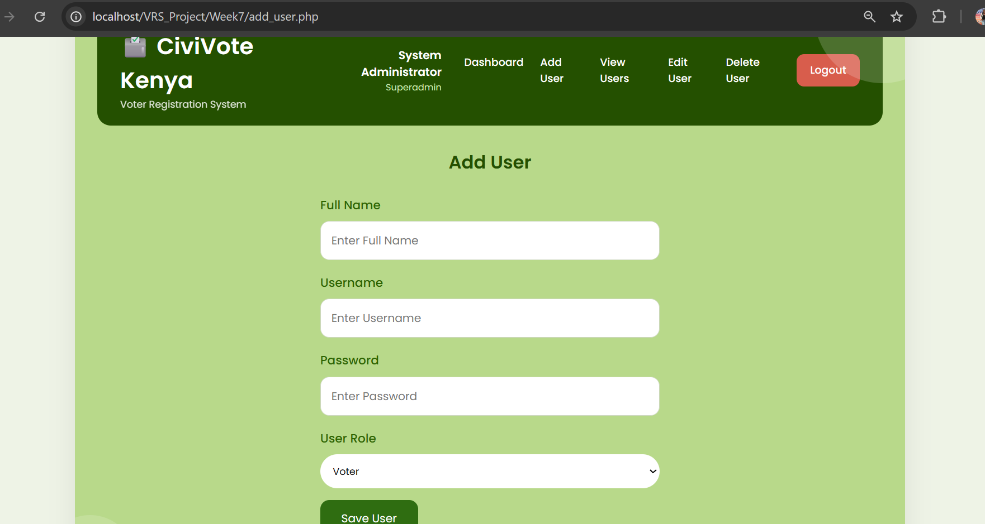
Figure 38: User Registration Form Accessible to the Super Administrator.

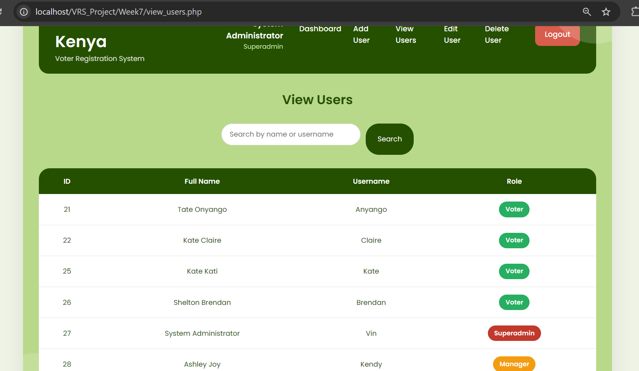
Figure 39: View Users Page Displaying Registered System Users.

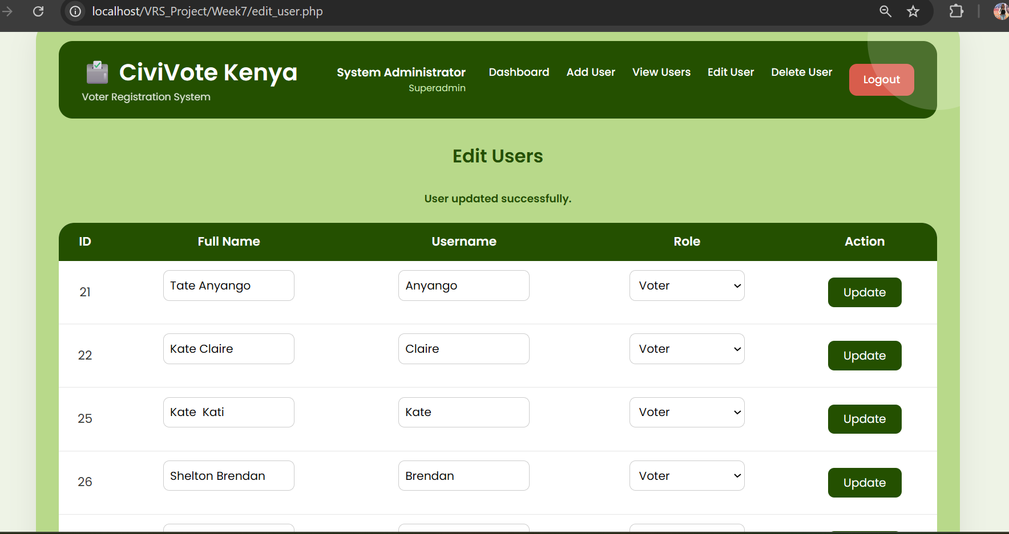
Figure 40: User Information Update Interface.
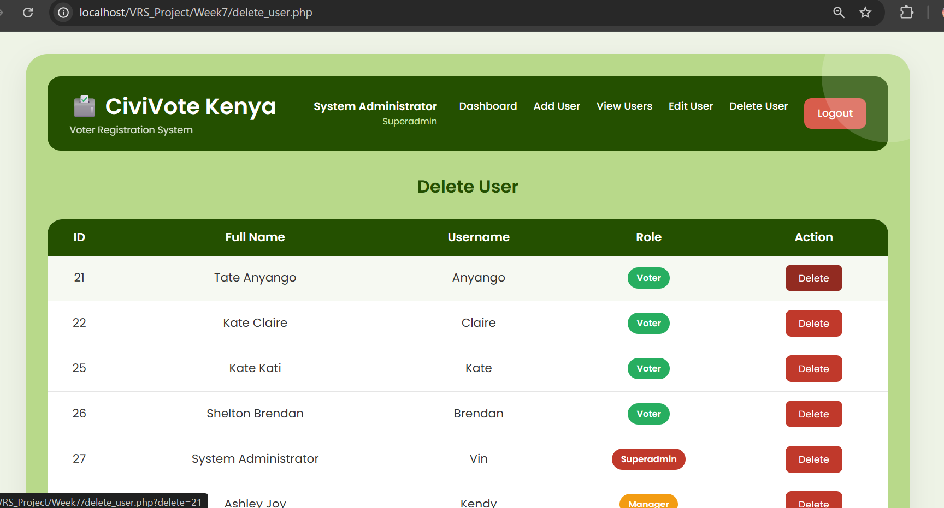
Figure 41: User Deletion Interface for System Administration.

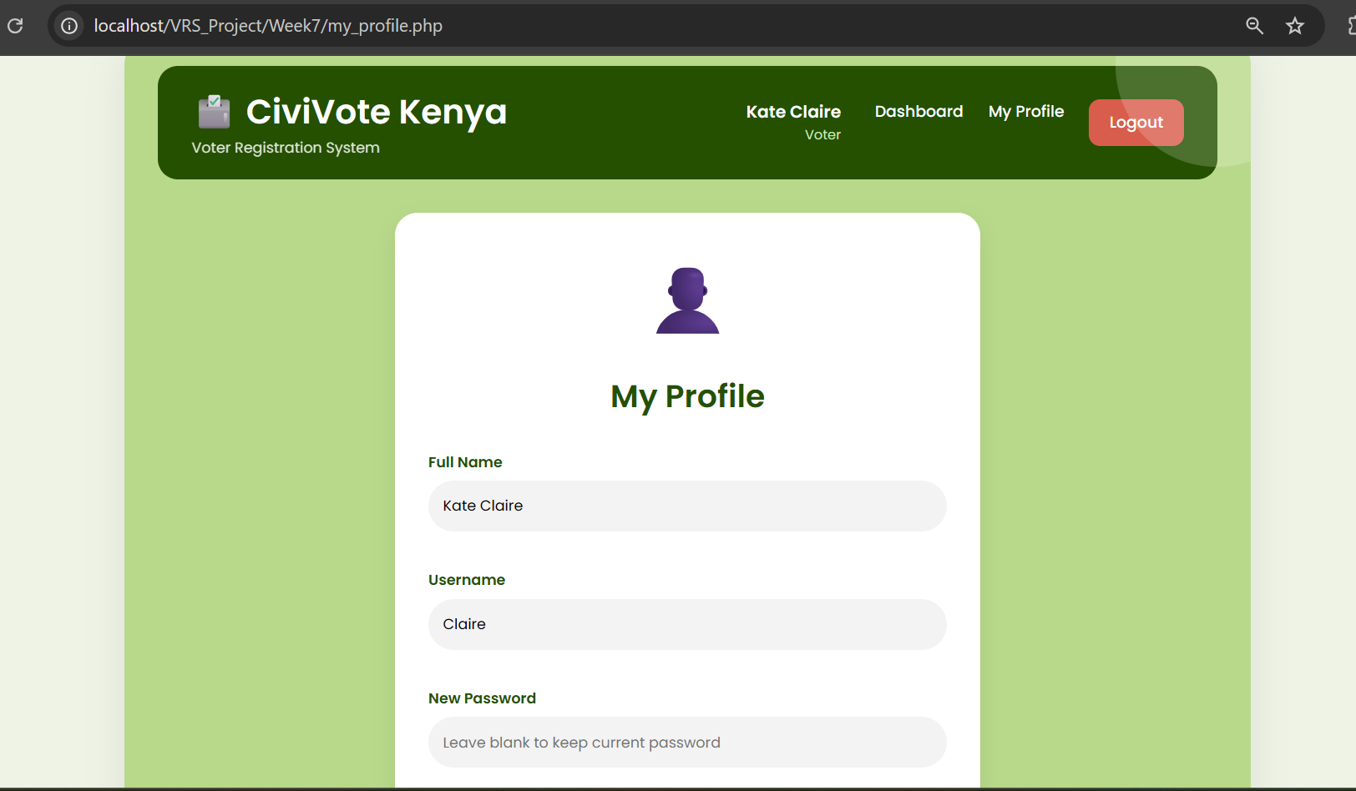
Figure 42: User Profile Management Page.

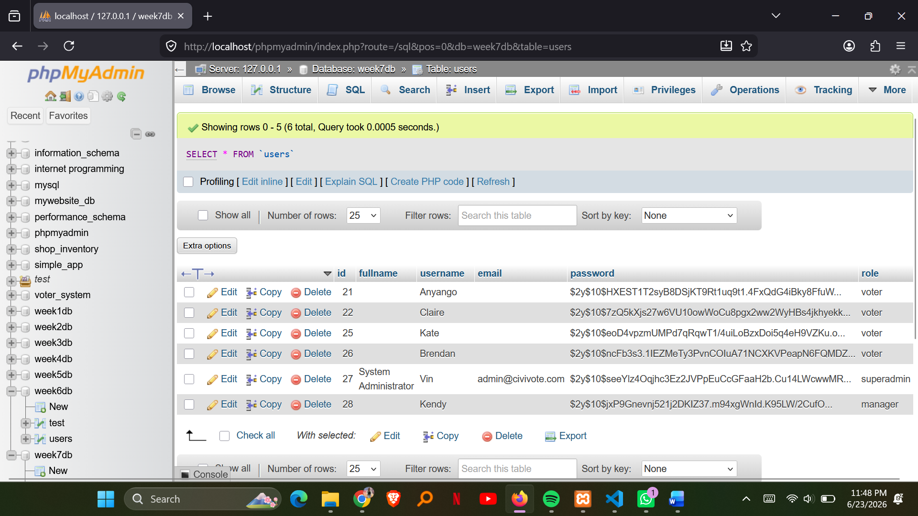
Figure 43: Passwords Stored in Hashed Format Within the Users Database Table.

